Title of the poster presentation or short talk

A. Presenter¹, B. Co-Author², C. Co-Author³

1 – University, Department, City, Country
2 – University, Department, City, Country
3 – University, Department, City, Country

Abstract
[Arial 11pt, normal font, left-justified,1.15 spacing]
[Starting with the second paragraph, indent 0.5 cm for the first line.]

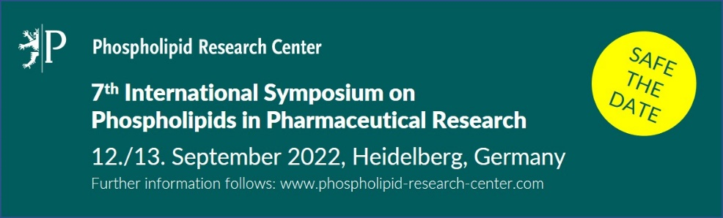
Figure 1: Description of Figure 1. [Arial 9pt, normal font, centered, 6pt space after, 1.15 spacing]

References
[1] Author A, Anotherauthor B, Lastauthor C, Title. Adv. Drug Deliv. Rev. 2022, 123, 45-67. DOI.
[2] [Arial 9pt, left-justified, 1.15 spacing]
[3]

