Final Report – ABC-2020-123/1-1
Title of Proposal
Principal Investigator:
Institute of Principal Investigator:

Address:

Phone:
E-mail:
Webpage:

Date:

A final report should not exceed 12 pages (without references).

Please indicate the name of the PI and the project number (ABC-2020-123/1-1) in the heading and footer.

Please delete all text marked in yellow in your report prior submission. Please delet everything that is not used (tables, figures).

INTRODUCTION
When writing your final report, it will be necessary to introduce your project more comprehensively (see template research proposal).

MATERIALS
List all used materials with trade name and utilized quality.

METHODS
Describe briefly your methods and procedures.

RESULTS
You can organize your results in tables as shown in “Table 1”. You can also use graphs or images. Captions should be numbered, e.g. ″Table 2″ or ″Figure 3″.
- For images, be sure to have a good resolution.
- Please note that the words “Figure” or “Table” should be spelled out.
- Arrange the tables and figures so that they are centered on the page.]

Please indicate in a table which work packages (compared to the contract) have been processed! This comparison is mandatory.

Table 1. Comparison of the work carried out with the approved and contracted work packages.
 |  | Carried out | Reason for not processing
WP1 | Title
WP2 | Title
WP3 | Title

Subheading 1
[…]

Subheading 2
[…]

Table 2. Captions should be in Arial, bold, 9pt.
Headline; Arial, bold, 10pt | Headline | Headline
Copy; Arial, 10pt | Copy | Copy
Copy | Copy | Copy

[…]
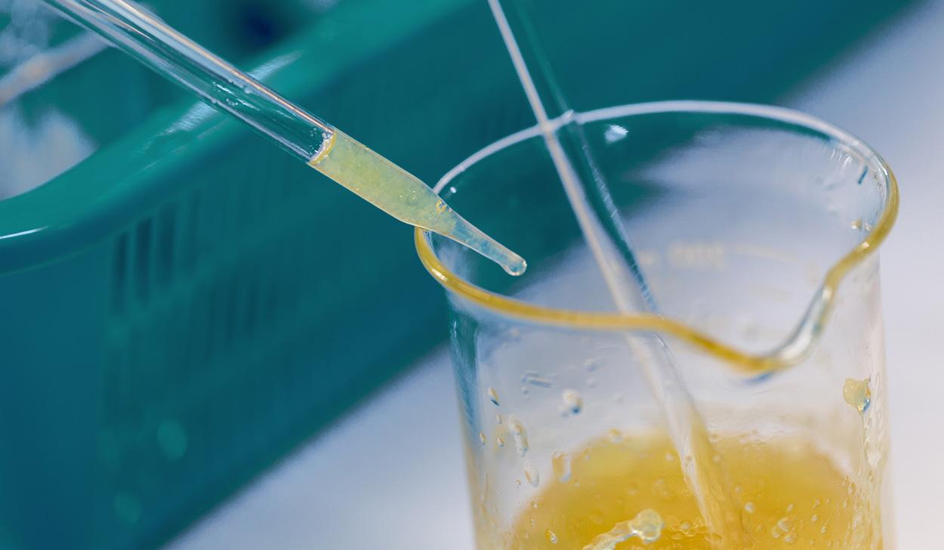

Figure 1. Captions should be in Arial, bold, 9pt. Be sure to have a good resolution of the image.
[…]
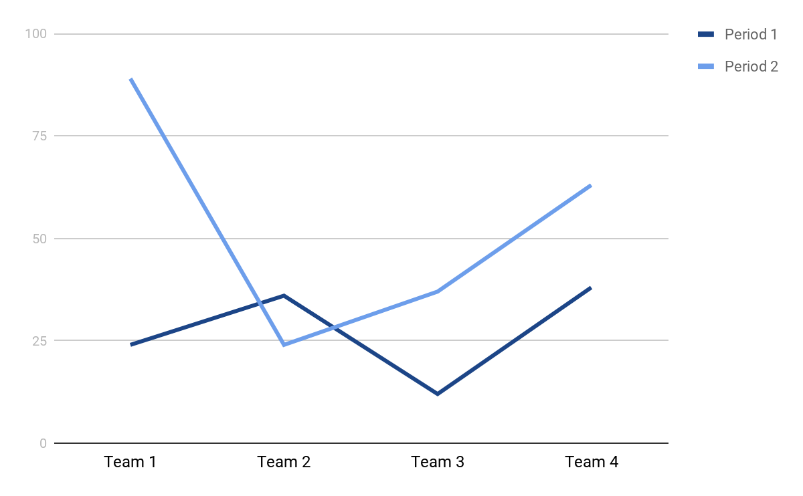

Figure 2. Captions should be in Arial, bold, 9pt.
[…]

DISCUSSION
Compare the results with the hypotheses and results of other researchers. Describe the impact of the findings on the use of phospholipids. You can also mention further planned steps and related scientific questions.

CONCLUSION
Draw conclusions in a concise manner. Were the aims achieved? Were or will the results (be) published?

Publications? Posters (add details); Journals (add details)

Up to this point, there should be no more than 12 pages.

REFERENCES
Mention literature references in the text and in this section using Harvard Style.

Examples:
[1] van Hoogevest, P., 2017. Review – An update on the use of oral phospholipid excipients. Eur. J. Pharm. Sci., 108, pp.1–12
[2] van Hoogevest, P., Wendel, A., 2014. The use of natural and synthetic phospholipids as pharmaceutical excipients. Eur. J. Lipid Sci. Technol., 116, pp.1088–1107.

Use a numbered list of references at the end of the report, ordered as they appear in the text. If the work has three or more authors, the abbreviation ‘et al.’ should be used after the first author’s name. Private communication should be acknowledged in the main text in brackets, not referenced, e.g. (van Hoogevest, personal communication).

SIGNED

Name of Principal Investigator | Date and place

